SECTION 15 - Farm & Garden
STEWARDS:
CHIEF STEWARD: Kate Robinsen phone: 0427 225 816 Email: gavco_ptyltd@westnet.com.au
ASSISTANT STEWARDS: Marlene Rennick, Alma Ferguson, Geoffrey Murray.
All entrants in Young Judges Competition are invited to participate as stewards.
ENTRIES:
ENTRIES SUBMISSION TIMES: WEDNESDAY 6th May 3PM - 6PM THURSDAY 7th MAY 7AM – 9AM
ENTRIES CLOSE THURSDAY 7th MAY, 2026 AT 9.00AM –
NO LATE ENTRIES WILL BE ACCEPTED
Other times by arrangement with Chief Steward only.
Entries can be done via Showday at romashow.com (preferred) or entry form delivered with your produce.
Entry Fee: $2.00 (gst incl) per entry
Entries to be delivered to the Farm & Garden (Wool) pavilion.
All vehicles delivering exhibits must be cleared from this area by 9.30 am Thursday 7th May 2026.

RIBBONS, TROPIES AND PRIZE MONEY:
First: $8.00 (gst incl)
Second: $5.00 (gst incl)
(Unless otherwise specified)
RULES & REGULATIONS:
In addition to the Roma Show Society Rules & Regulations listed at the front of the main schedule, the following will apply to this section.
1. Exhibits received after 9.00 am, Thursday 7th May 2026, will not be accepted.
2. All entries must be grown by the exhibitor.
3. All classes must be harvested within 12 months of the Show date or otherwise stated.
4. No distinguishing marks to be left on any exhibit.
5. Points are allocated for presentation of entries.
6. Any competitors selling their produce are obliged to donate 20% commission to the Roma Show Society Inc.
7. The Pavilion closes to the public at 5pm on Saturday 9th May 2026 and entries to be collected
between 5pm and 6pm Saturday and on Sunday 10th May between 8am and 10am.
8. No pickled grain to be entered.
9. All prize money is to be collected from the main office on Saturday 9th May 2026 between 4 and 6pm. After this time, all unclaimed prize money will be donated back to the show, it the responsibility of the winner to collect his or her prize money.
10. Competitors Declaration - All competitors and exhibitors have read and understand the Rules and Regulations and agree to be bound in all respects by these Rules and Regulations. Competitors and exhibitors also consent and agree that the Roma Show Society has the right to take or use photographs of him or her (and/or your property) and use the photos in any and all marketing and media worldwide, including online, now and in the future. All entrants compete at their own risk. No claim in any form shall be made by the entrant, their families, friends and/or
representative against the Roma Show Society or person/s associated with the holding of the
competition/exhibit.

*****PLEASE NOTE: Schedules are subject to change at any time and without notice****
DIVISION A
Pumpkins
Class 1501 One Pumpkin - Qld Blue
Class 1502 One Pumpkin - Jarrahdale
Class 1503 One Pumpkin - Butternut
Class 1504 One Pumpkin - Kent (Jap)
Class 1505 One Pumpkin - any other variety
CHAMPION EDIBLE PUMPKIN FROM CLASSES 1-5
Class 1506 Collection of Pumpkins - each a distinct variety
Class 1507 Biggest Pumpkin - any variety - judged on size
Cucurbits
Class 1508 One Marrow or Zucchini
Class 1509 One Squash
Class 1510 One Cucumber
Class 1511 Collection of Cucurbits from Class 8, 9 and or 10
Vegetables
Class 1512 Two Beetroot - leaves attached.
Class 1513 Two Carrots - tops attached.
Class 1514 Two Potatoes/Sweet Potatoes
Class 1515 Two Allium
- i.e. Onion x 2, Garlic x 2 etc., Chives, Leek, Shallot, Scallion (Spring Onion)
Class 1516 Head of Brassica - i.e. Cabbage, Broccoli, Cauliflower
Class 1517 Head of Lettuce
(Suggestion Displayed in Glass jar with water)
Class 1518 Two Corn Cobs
Class 1519 Plate of any variety of Bean
Class 1520 Two Capsicum or Two Chili
Class 1521 Any other Vegetable not specified.
Class 1522 Collection of Vegetables - no less than three varieties
Class 1523 Silver beet, Spinach and Chard
Class 1524 The One That Got Away' Vegetable
- not judged on taste but on size
CHAMPION EDIBLE VEGETABLE
FROM CLASSES 8-11 and 12-25
Class 1525 Basket of soup vegetables - minimum of 4 different varieties
Miscellaneous - Herbs & Mushroom
Class 1526 One Single herb sprig
Class 1527 Collection of Herbs -
entries to have at least Three herbs and list provide
Class 1528 One Herb grown in pot (Potted herb)
Class 1529 One edible Mushroom any variety
CHAMPION MISCELLANEOUS - HERBS & MUSHROOM
CLASSES 26-28
DIVISION B
Citrus Fruit
Class 1530 Two Grapefruit
Class 1531 Two Mandarins
Class 1532 Two Oranges
Class 1533 Two Lemons
Class 1534 Two Citrus - any other variety
Other Produce
Class 1535 Three Tomatoes
Class 1536 One Water Melon
Class 1537 One Rock Melon
Class 1538 Plate of Rosellas
Class 1539 Two of any other one fruit not specified.
Class 1540 Collection of Fruit - no less than three varieties
CHAMPION FRUIT
FROM CLASSES 29-39
Eggs
- to be displayed in half cardboard carton with egg point down
Class 1541 Six Plain Brown Hen Eggs
Class 1542 Six Plain White Hen Eggs
Class 1543 Six any other colour Hen Eggs
Class 1544 Six any colour any other Bird Egg
CHAMPION EGGS
FROM CLASSES 40-43
DIVISION C
Grains - Summer
Displayed in Clear Bags
Class 1545 Sorghum - 4kgs
Class 1546 Mung Beans - 4kgs
Grains - Winter
Displayed in Clear Bags
Class 1547 Wheat - 4kgs
Class 1548 Barley - 4kgs
Class 1549 Chickpeas - 4kg
Class 1550 Oats - 4kg
CHAMPION GRAIN
FROM CLASSES 44-49
Hay
Class 1551 Lucerne - Entry size -1 Biscuit
Class 1552 Oats - Entry Size - 1 Biscuit
Class 1553 Barley - Entry Size - 1 Biscuit
Class 1554 Sorghum - Entry Size - 1 Biscuit
Chaff
Class 1555 Lucerne - Entry Size - 1 Biscuit
Class 1556 Oats - Entry Size - 1 Biscuit
Class 1557 Barley - Entry Size - 1 Biscuit
Class 1558 Sorghum - Entry Size - 1 Biscuit CHAMP
CHAMPION HAY & CHAFF
CLASSES 50-57
Prize Voucher Donated by
GRAND CHAMPION EXHIBITOR - MOST POINTS IN DIVISION A, B & C
Trophy donated by Mrs Alanah Ladbrook President Roma Show Society
JUNIOR DIVISION
For children aged 14 years & under
Fruit & Vegetables
Class 1559 One Pumpkin any variety
Class 1560 Any One Squash, Marrow or Zucchini
Class 1561 Any other Two Vegetables - i.e. Carrot & Bean or Potato & Parsnip
Class 1562 Any Two Fruit - i.e. Orange & Rock Melon or Tomato & Orange
Class 1563 Display of Fruit/Vegetables
Class 1564 Collection of herbs - three or more
Class 1565 Six Hen eggs in a half cardboard carton with egg point down.
Class 1566 Novelty - Best Dressed Fruit or Vegetable (For example - Mr Potato Head)
Class 1567 Best School Exhibit
– Exhibits will be judged on variety of produce, quality of exhibits and
presentation of display
CHAMPION JUNIOR EXHIBIT Farm & Garden
FARM AND GARDEN JUNIOR JUDGES
Junior Judges are invited to act as stewards and will be judged on their ability to
assess and judge a selected class. Entrants will provide reasons
for their choice.
Trophy and Prizemoney donated by
Class 1568 Junior Farm and Garden Judge under 13 years
Class 1569 Junior Farm and Garden Judge 13 years and under 18 years
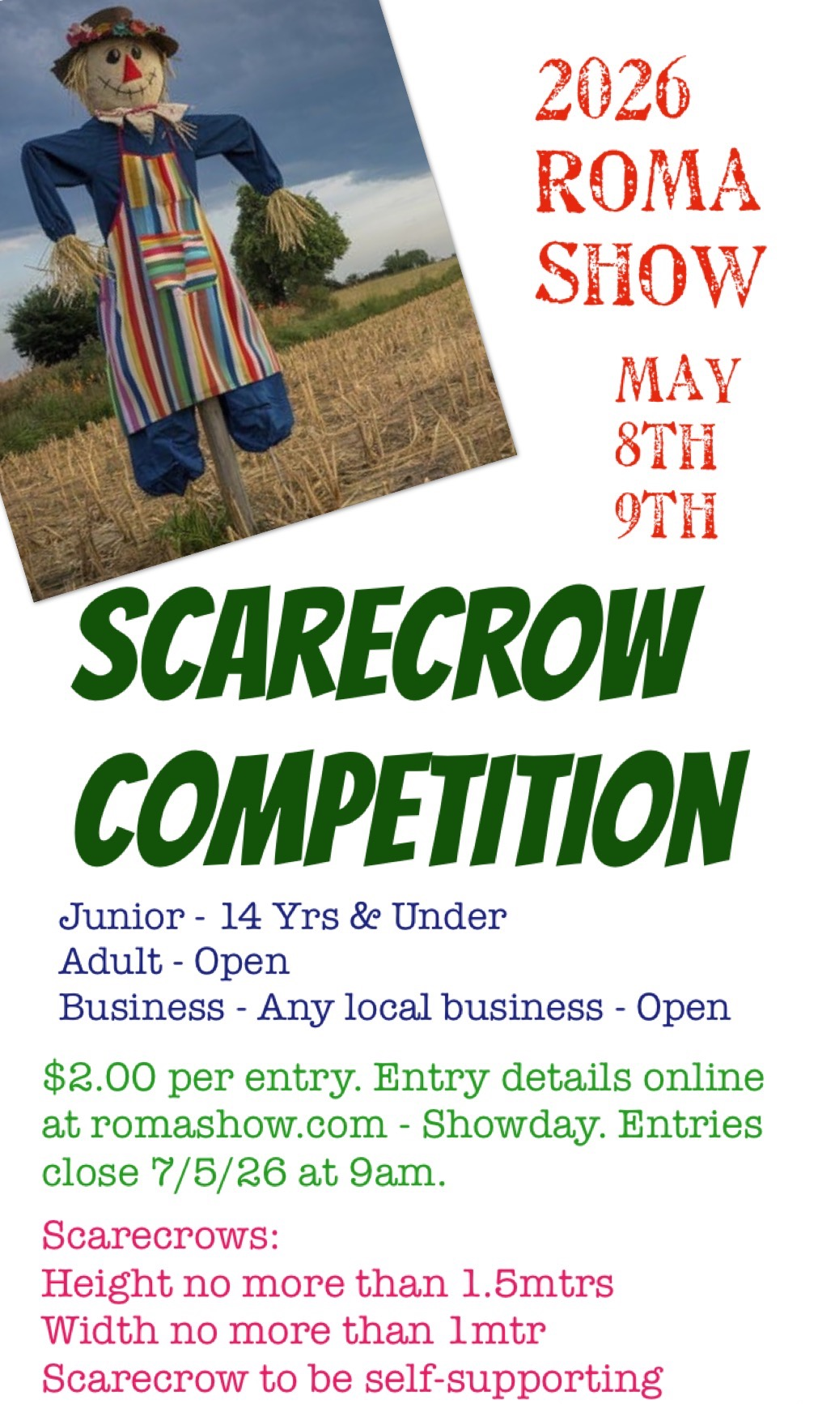
SCARECROWS
Height to be no more than 1.5metres
Width to be no more than 1 metre
Scarecrow is to be self-supporting.
Entries may be individual, school class, club or group effort.

First Prize - $15.00 (gst incl);
Second Prize - $10.00 (gst incl).
Class 1570 Junior Scarecrow 14 Yrs and under any category e.g. happy, scary
Class 1571 Adult Scarecrow - Open Category
Class 1572 Business Category - Any local business Open

